**Model Documentation: WDE-CNN-LSTM Architecture**

This is the documentation for the model combining Word Embedding (WDE), Convolutional Neural Networks (CNN), and Long Short-Term Memory (LSTM) layers. This model architecture is designed for text classification tasks.

**Model Overview:**

The model architecture consists of an embedding layer, a convolutional branch, an LSTM branch, and a final dense layer for classification.

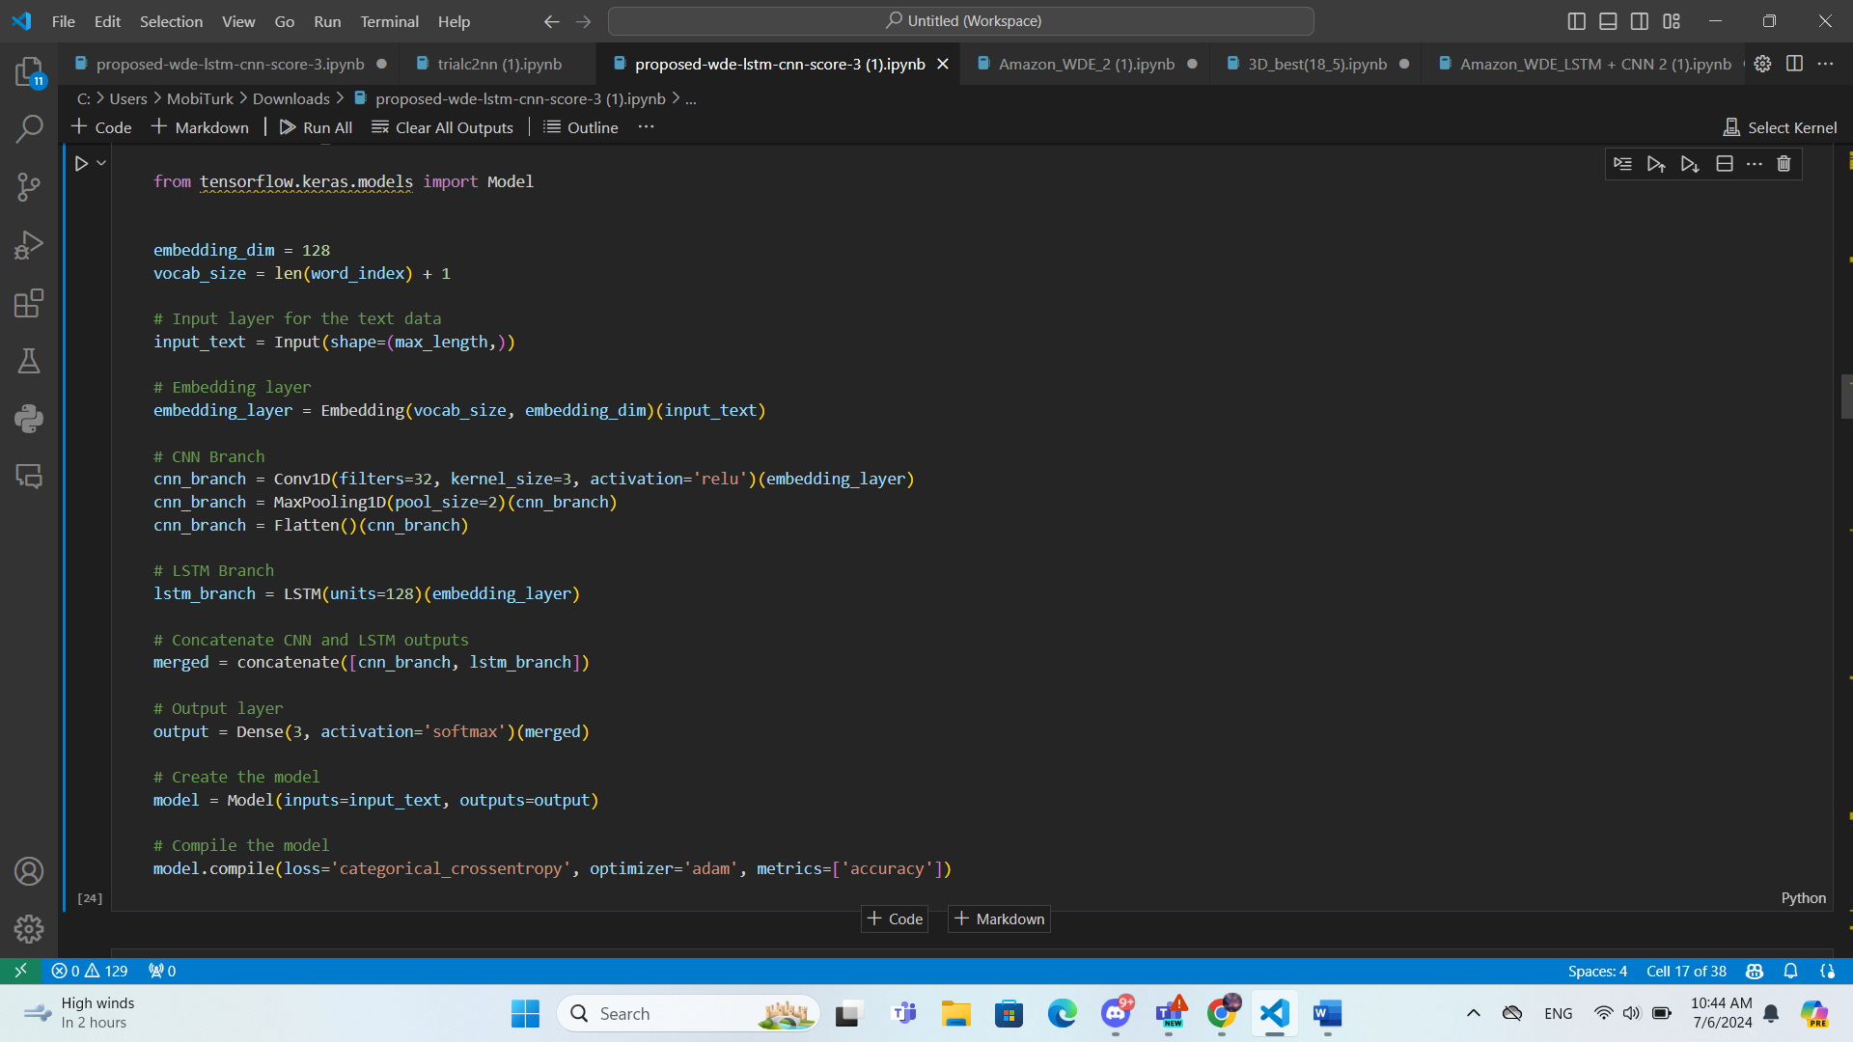**Architecture Diagram:**

**Architecture Description:**

1. **Input Layer**:
   * Input shape: (max_length,)
   * This layer accepts the input text sequences.
2. **Embedding Layer**:
   * Embedding dimension: 128
   * This layer converts the input text sequences into dense vector representations.
3. **CNN Branch**:
   * **Conv1D Layer**: Applies 32 filters with a kernel size of 3.
   * **MaxPooling1D Layer**: Reduces the dimensionality by applying a pooling operation with a pool size of 2.
   * **Flatten Layer**: Flattens the output from the convolutional layers to prepare it for concatenation.
4. **LSTM Branch**:
   * **LSTM Layer**: Contains 128 units that process the input sequence and capture the temporal dependencies.
5. **Concatenate Layer**:
   * Merges the outputs from the CNN and LSTM branches to combine the learned features.
6. **Output Layer**:
   * **Dense Layer**: Applies a dense layer with (5, or 3, or 2) output units and a softmax activation function for classification.

**Model Compilation**

* **Loss Function**: Categorical Crossentropy (Binary Crossentropy for 2 score)
* **Optimizer**: Adam
* **Metrics**: Accuracy

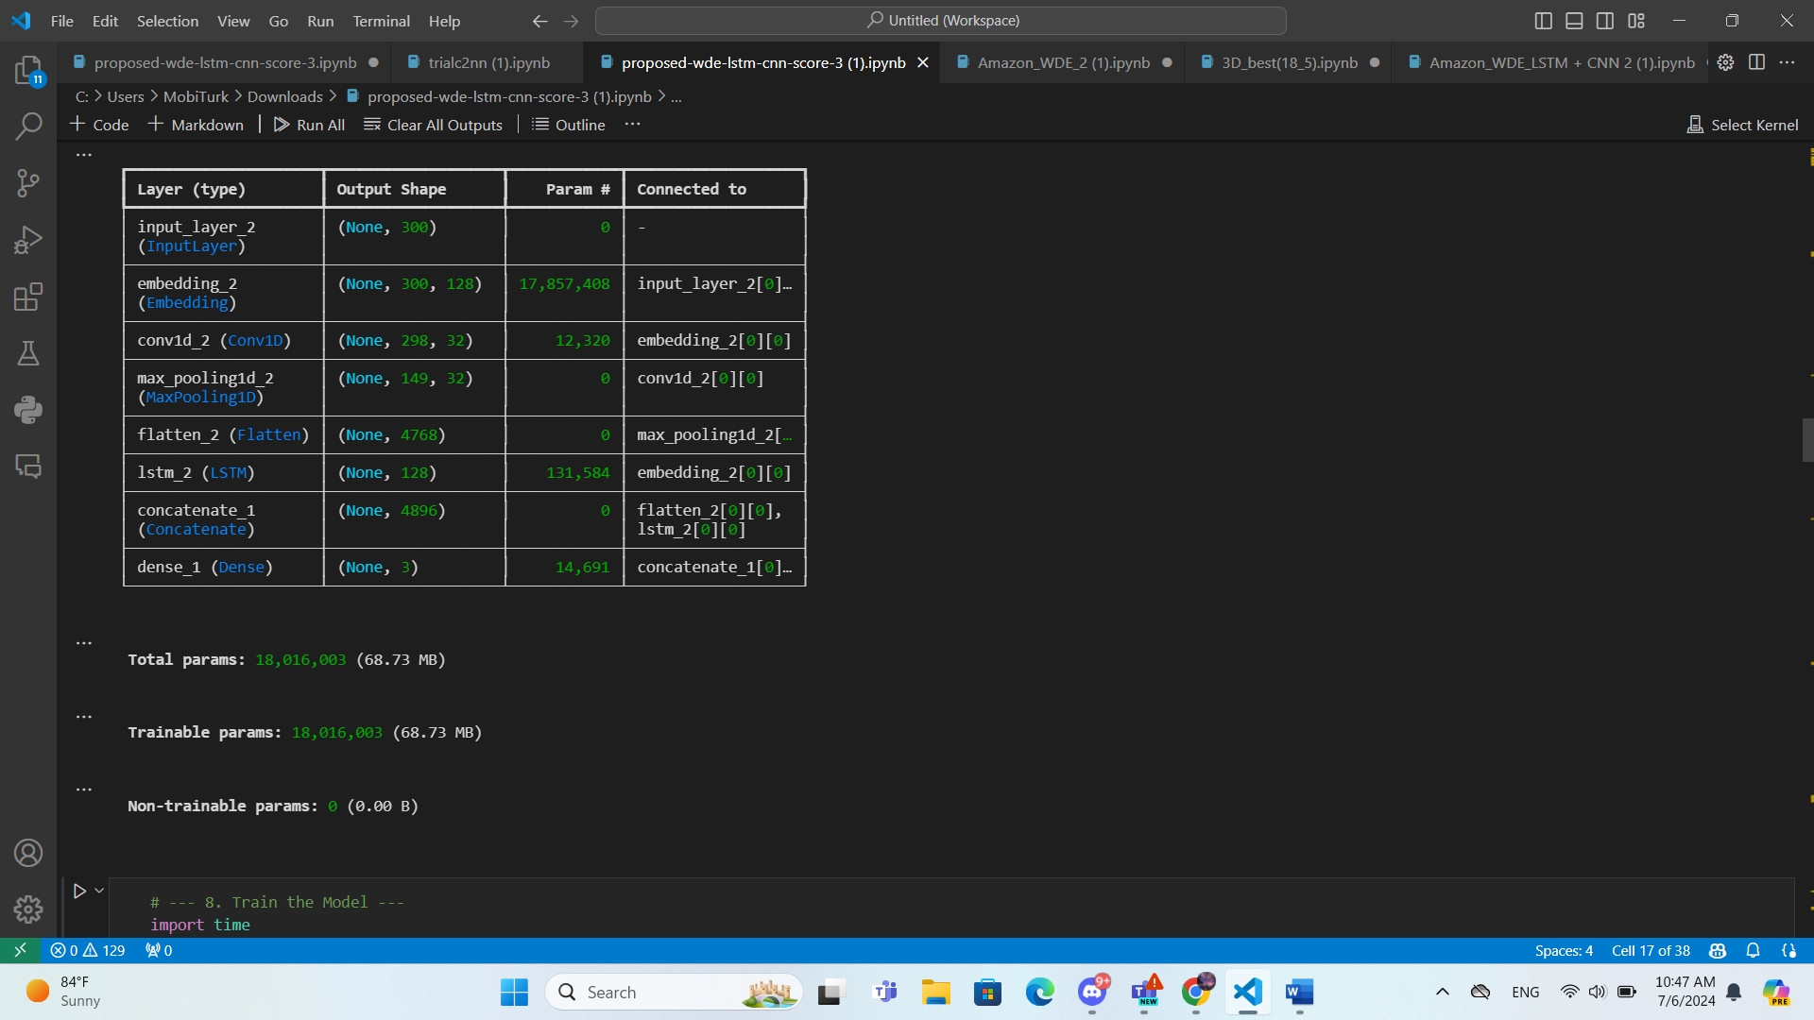**Model Summary:**